# Inheritance

Inheritance is the capability of one class to derive or inherit the properties from another class. The benefits of inheritance are:

1. It represents real-world relationships well.
2. It provides **reusability** of a code. We don’t have to write the same code again and again. Also, it allows us to add more features to a class without modifying it.
3. It is transitive in nature, which means that if class B inherits from another class A, then all the subclasses of B would automatically inherit from class A.

### Python Inheritance Syntax

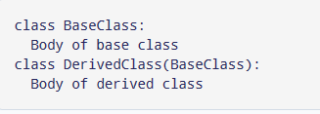

## Single class inherited example

class A:

    def __init__(self,name,roll,age):

        self.name=name

        self.roll=roll

        self.age=age

    def fun2(self):

        print("hello my mane is"+self.name+"my roll is"+self.roll+"my age is"+self.age)

class B(A):

    pass

sos=B("mahmud","12345","25")

sos.fun2()

Another example:

class Person:

    def __init__(self, name):

        self.name = name

    def getName(self):

        return self.name

    def isEmployee(self):

        return False

class Employee(Person):

    def isEmployee(self):

        return True

sos = Person("mahmud")

print(sos.getName(), sos.isEmployee())

sos = Employee("amyaa")

print(sos.getName(), sos.isEmployee())

## Multiple inheritance in Python

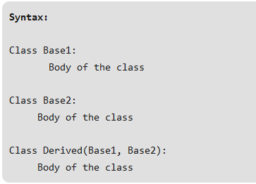

class Class1:

    def m(self):

        print("In Class1")

class Class2(Class1):

    def m(self):

        print("In Class2")

class Class3(Class1):

    def m(self):

        print("In Class3")

class Class4(Class2, Class3):

    pass

obj = Class4()

obj.m()

**When method is overridden in one of the classes**

class Class1:

    def m(self):

        print("In Class1")

class Class2(Class1):

    pass

class Class3(Class1):

    def m(self):

        print("In Class3")

class Class4(Class2, Class3):

    pass

obj = Class4()

obj.m()

**When every class defines the same method**

class Class1:

    def m(self):

        print("In Class1")

class Class2(Class1):

    def m(self):

        print("In Class2")

class Class3(Class1):

    def m(self):

         print("In Class3")

class Class4(Class2, Class3):

    def m(self):

        print("In Class4")

obj = Class4()

obj.m()

Class2.m(obj)

Class3.m(obj)

Class1.m(obj)